Program 1: Installing Maven and Gradle: Overview of Build Automation Tools, Key Differences Between Maven and Gradle, Installation and Setup

Installation and Setup
Java (JDK) Installation:

Step 1: Type the command sudo apt install openjdk-11-jdk -y in the terminal
It will install the OpenJDK 17 automatically.

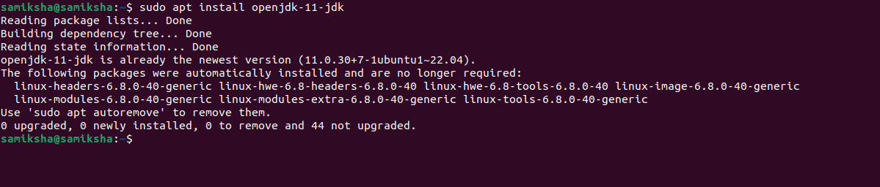
Step 2: Installation can be confirmed by running the command java -version

Maven Installation:
Step 1: Type the command sudo apt install maven in the terminal.
It will install Apache Maven from Ubuntu's package repository.
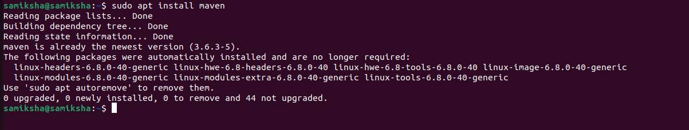

Step 2: Installation can be confirmed by running the command mvn -version
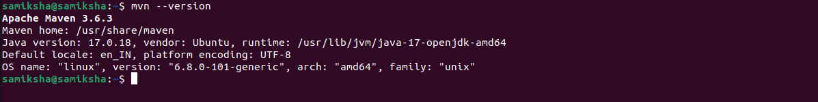

Gradle Installation:
Step 1: Type the command sudo apt install gradle in the terminal
It installs Gradle build automation tool from Ubuntu's package repository.

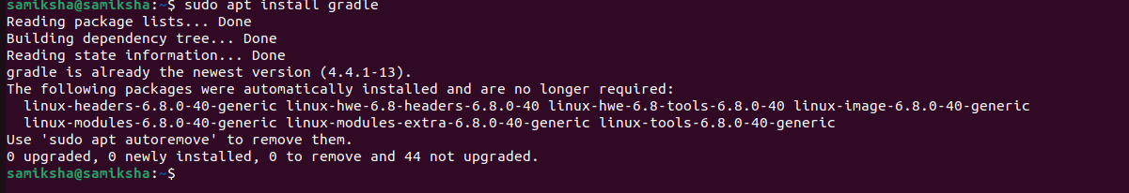
Step 2: To check the proper installation of Gradle run the command gradle –version
